**Santander Consumer**

**Bank Norway**

Business Design Specifications

**CRXXX – Calculator Widget**

|  |  |
| --- | --- |
| Information Classification | Santander Consumer Internal |
| Distribution | Internal & External |
| Access | Santander Consumer Internal |

# Content

1 Content 2

2 Introduction 3

2.1 Purpose of Document 3

3 Functional Overview 4

3.1 Background 4

3.2 Requirements 5

4 High Level Solution 7

4.1 Changes 7

4.1.1 Create stylable calculator widget to be inserted in webshops 7

4.1.2 Create a calculator preview page 8

4.2 Technical description 8

4.3 Estimate 9

5 Testing 10

5.1 Test description 10

# Introduction

## 

## Purpose of Document

The purpose of this document is to specify a solution for creating a calculator widget to be used in partner websites.

# Functional Overview

## Background

An important tool in selling consumer goods in webshops is to offer financing. The current solution for this is a widget/snippet provided by Payever. When a webshop page is loaded a request towards Payever is initiated and simple “calculator” is injected in the webshop where different monthly payments have been pre-calculated.

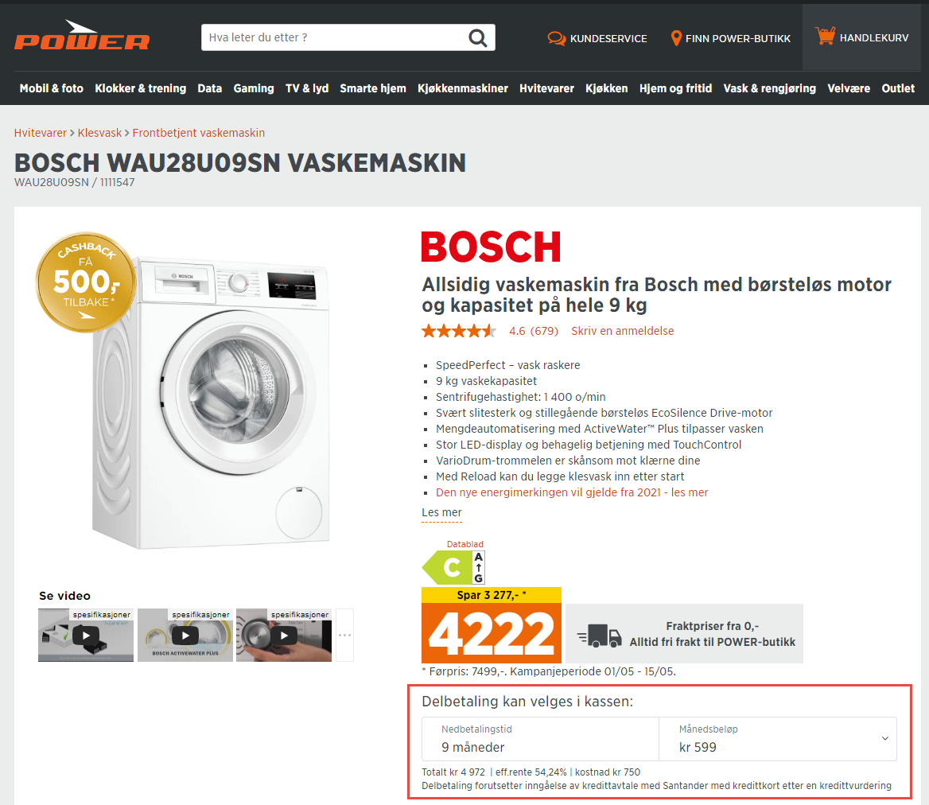

This solution works fine but Santander is now in the process of replacing Payever with Bamboora. Bamboora does not have widget support and Santander is therefore looking for a solution for this.

## Requirements

The solution should support the following requirements:

1. The widget shall precalculate downpayment and monthly amount given a fixed interest using the matrix provided below

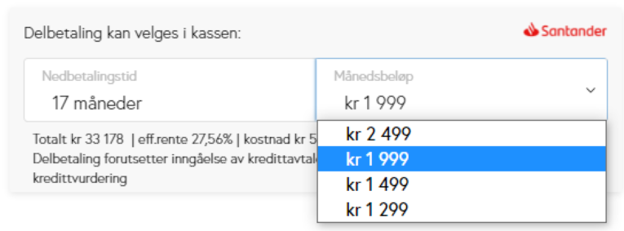

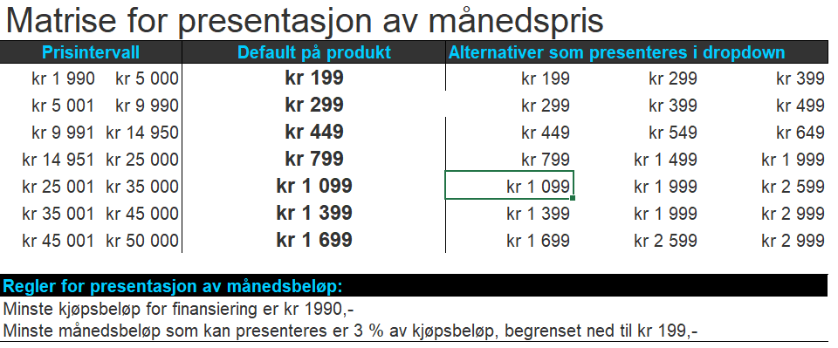

1. The widget shall have high performance and load really fast in webshop/parent
2. The widghet shall support “refresh” when purchase amount changes in webshop/parent
3. The widget shall support styling:

* Santander logo visible/not-visible
* Background and border color
* Heading “Delbetaling kan velges i kassen» font face and size
* Language support (NO/SEK/DK) for text
* Set width and hight
* Modern vs classic look (left vs right below)

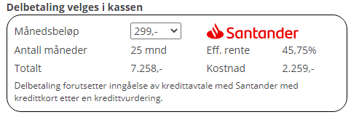  
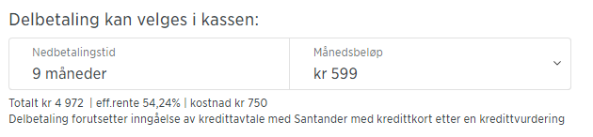

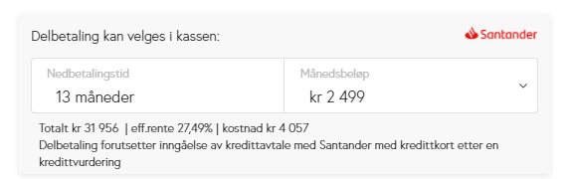

1. A sandbox/ WYSIWYG page should be included. This should be a page where the user visually can change the component and preview the changes. When finished, the user can “copy code” and get working javascript code that can be pasted into webshop/parent
2. The widget should easily be embedded in partners webshop regardless of the coding framework used

# High Level Solution

## Changes

### Create stylable calculator widget to be inserted in webshops

* 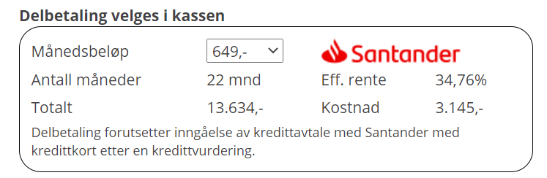A widget should be created where monthly amount is a dropdown with pre-calculated values



* The POS client calculator should be re-used in order to maintain “one source of truth” when it comes to calculation and its business rules

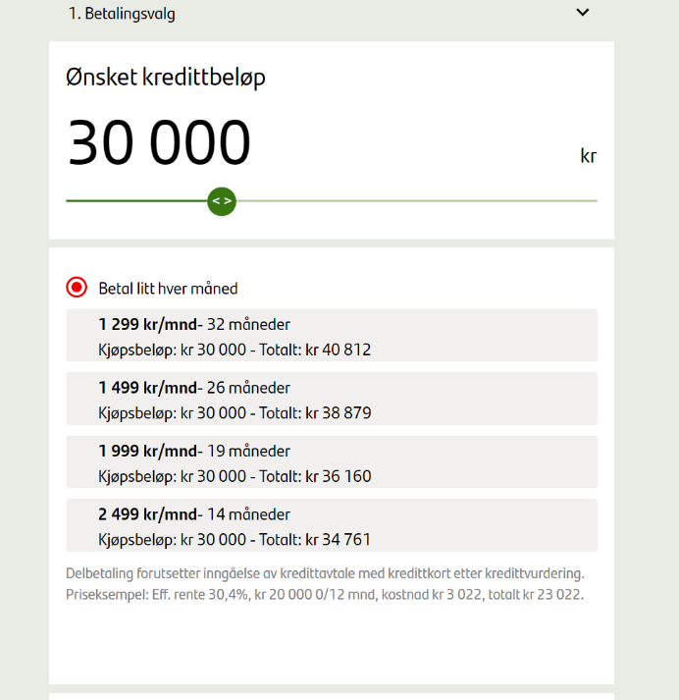

* The new widget should be hosted as part of the POS solution in order to avoid introducing new sites and setup
* In version 1, there will only be one calculator with common conditions (interest and fees) for all partners/webshops

### Create a calculator preview page

Within the existing POS solution (for instance pos.scb.no/partner) a preview of the calculator will be displayed. This will be publicly available, i.e. it will not be protected behind a login.   
  
Next to the calculator, a panel will be displayed where UI styles and layout can be changed. When the user is content with the layout changes the javascript code can be copied and pasted into the webshop/partner site.

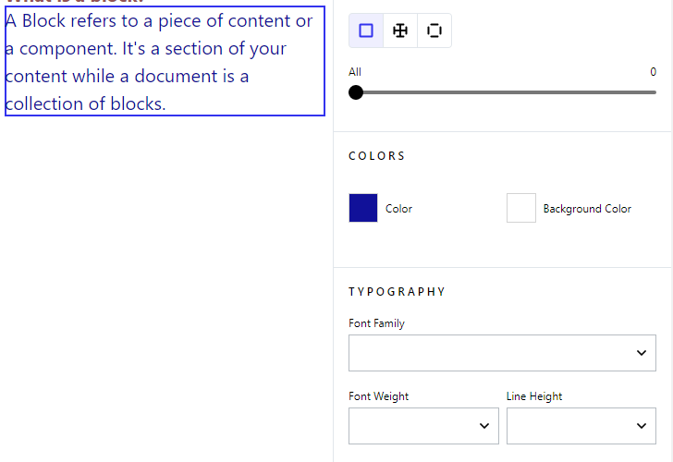

## Estimate

|  |  |  |
| --- | --- | --- |
| System | Task | Estimate |
|  | Develop a pluggable widget component and host it along with POS |  |
|  | Develop a web-app as playground to show how the widget can be configured visually and host it along with POS |  |
|  | **Sum development** |  |
|  |  |  |
|  | Testing |  |
|  | Documentation |  |
|  | **Total** |  |

# Testing

## Test description

* Test calculator according to business rules provided by Santander